[uw unit] Shop Safety Plan

Last Reviewed/updated on [APRIL 2024]

Table of Contents
[uw unit] Shop Safety Plan 1
1. Introduction 4
2. Scope 4
3. Roles and Responsibilities 4
4. Shop safety requirements 7
Shop Emergency Contact Information 7
Access control 8
Access to safety information 8
Housekeeping 8
Hazard communication 9
Working alone 10
Safety training 11
Personal protective equipment (PPE) 12
Minimum Shop Attire 13
Specific activity and process hazard assessments 13
Incident response 15
Reporting incidents 15
Safety self-inspections 16
5. Definitions 16
6. References 17
Appendix A: Sample Documentation Form 18
Appendix B: Shop Safety Self-Inspection Checklist 19
Appendix C: Training Records Logs 22
Example Shop Safety Training Log 22
Equipment-Specific Safety Training Log 23
Shop-Specific Safety Training Log 23
Additional Shop-Specific Safety Training Log 24
Appendix D: Machine safeguarding 25
Hierarchy of Controls for machine safeguarding: Examples 26
Appendix E: Signage and Labeling 27
Required shop signage 27
Recommended shop signage 27
Chemical containers 28
Piping systems 28

Introduction
The purpose of the Shop Safety Plan is to help address the potential hazards and risks associated with shops and maker spaces and to prevent injuries and incidents from occurring. University units with shop and maker spaces are responsible to ensure the this template is customized and completed as a component of their Supplemental Accident Prevention Plan to meet the requirements in Washington Administrative Code, WAC 296-800, WAC 296-806 and WAC 296-807 enforced by the Washington State Department of Labor and Industries (L&I), Department of Occupational Safety and Health (DOSH).

Scope
The policies and procedures in the Shop Safety Plan apply at all University owned and operated locations shops and maker spaces for personnel and students. This includes the Seattle campus, UW Bothell, UW Tacoma, and other University-owned property. University-leased spaces, and temporary field locations that are under the control and supervision of UW personnel.
This plan applies to any space that meets the definition of a shop as defined in the Definitions Section. Locations that do not meet the definition of a shop may refer to this plan for general safety.
[Name of Unit/Department] personnel authorized to work in the shop or maker space, or work with shop equipment:
- [list job or work assignment titles and types and/or tasks]

Roles and Responsibilities
Role | Responsibilities
Unit/Department administrator or upper management | - Accountable for safe and compliant operation of shops and maker spaces in their unit/departments.  - Ensure appropriate resources are provided to support the safe operations of shops and maker spaces.  - Ensure that shop safety plans are developed and maintained of shop safety plans for all shop locations.  - Appoint a qualified individual to serve as the shop safety coordinator.  - Inform new shop safety coordinator(s) of shop safety plan requirements.  - Notify Environmental Health & Safety of new shops and the assigned shop safety coordinator.
Principal Investigator (PI)/Shop Manager/Responsible Person | - Develop and maintain the shop safety plan.  - Ensure this plan is reviewed with personnel, implemented, and followed by all personnel.  - Ensure shop participation in Environmental Health & Safety shop safety inspections.  - Ensure personnel complete safety training and train direct reports on any unit or site-specific safety measures in places. Ensure training is documented.  - Obtain and maintain required permits (e.g., local fire department).  - Determine and implement mitigations to address shop safety inspection findings (recommendations).  - Ensure all recommendations are addressed in a timely manner.  - Address or escalate reported or observed safety concerns to a unit leader or to EH&S.  - Ensure all incidents are reported in OARS. Report to EH&S immediately if a personal injury results in a fatality, hospitalization, amputation, or loss of eye.
Shop safety coordinator | - Be familiar with shop operations, hazards, and hazard controls specific to the shop.  - Support the development, review, and maintenance of the shop safety plan.  - Ensure personnel in shops complete required EH&S training for operations.  - Conduct and document shop-specific training on shop equipment, safe work practices and processes, and emergency procedures.  - Maintain all training records and are accessible for shop inspection.  - Restrict access to the shop and shop equipment to authorized personnel during authorized operating hours.  - Maintain a safe environment and restrict access to unsafe facilities, equipment, and tools.  - Enforce safety rules and procedures.  - Enter and maintain a list of chemicals used and stored in the shop in MyChem.  - Ensure personnel have access to chemical safety data sheets (SDS).  - Identify and assess hazards in the shop and/or associated with the use and maintenance of shop equipment.  - Support the Identification, implementation, and effectiveness of hazard controls.  - Maintain shop documentation (e.g., shop safety plan, safety data sheets, job hazard analyses or standard operating procedures, machine guarding assessments, etc.).  - Ensure signage/labels are in place.  - Ensure personal protective equipment (PPE) is maintained, readily available, and used when needed.  - Investigate and report accidents and incidents, including near misses, using the Online Accident Reporting System (OARS).  - Perform shop safety self-inspections and follow-up on corrective actions identified through self-inspections.  - Coordinate and participate in Environmental Health & Safety shop safety inspections and accident investigations.  - Support implementation and tracking of mitigations identified from EH&S inspection findings.  - Ensure visitor safety (including contractors).  - Enforce restrictions on children, minors, and pets.
Environmental Health & Safety (EH&S) | - Oversee University shop and maker space safety and compliance.  - Maintain Shop Safety Program to meet or exceed regulatory requirements.  - Conduct shop safety inspections at least every 2 years, or as determined by EH&S) and work with shops and units to address findings.  - Escalate outstanding findings or issues of immediate safety to unit leadership per EH&S escalation procedures.  - Inform shop safety coordinators, PIs and Managers, and unit/department leadership of program requirements and updates.  - Advise and assist shops with shop safety issues and procedures, as requested.  - Provide access to general safety training courses.  - Maintain a database of safety data sheets (SDSs) in MyChem.  - Maintain Shop safety website with requirements and resources.  - Investigate shop incidents or accidents.
Authorized personnel | - Authorized personnel include personnel and students trained to use shop equipment and work in shop area. Students considered minors, under the age of 18, authorized to use shop equipment must adhere to the requirements for minors in labs and shops per the UW Policies and Laws regarding Minors Webpage.  - Know and comply with safety guidelines and policies required for all assigned tasks.  - Complete all required and assigned safety training prior to using shop equipment.  - Report unsafe conditions to your shop’s safety coordinator, your immediate supervisor, or EH&S.  - Evaluate procedures and assigned tasks; perform them only after you believe the risk is at an acceptable level.  - Select, maintain, and use PPE appropriately, consistent with your training and shop rules. Report accidents and incidents (including near misses) to your supervisor, and to the University using the Online Accident Reporting System (OARS).

Shop safety requirements
Supervisors are required to:
- Create a Shop Safety Plan using this template; and
- Review it with personnel initially, annually, and when updates are needed.
Evaluate and consider the specific equipment and conditions (e.g., machine guarding, cranes and hoists, portable tools, hot work, personal protective equipment, etc.) during your worksite projects and activities to successfully tailor this plan and procedures.
Attachment A can be used to document the review of this plan with unit/department personnel.
Shop safety coordinators, supervisors, and authorized personnel share responsibility for safety when working in the shop or maker space, or with shop tools.
Template Instructions: The shop safety coordinator or a designee must complete the highlighted sections with shop-specific information, as applicable. Update the plan every two years (at minimum). Review this information with authorized personnel, prior to shop activities and when there are changes to the plan.

Shop Emergency Contact Information
Click or tap here to enter text.
Click or tap here to enter text.
Click or tap here to enter text.
Click or tap here to enter text.
Click or tap here to enter text.
Click or tap here to enter text.
Click or tap here to enter text.

Access control
Limiting and controlling access is critical to preventing untrained or unauthorized persons from incurring injury. This is particularly true in an academic setting where a shop may be part of a group of rooms in a large building with several occupants.
Instructions: Provide a description of how access is controlled, if there are specific operating hours and instructions for access to the shop, after normal operating hours.
Click or tap here to enter text.

Access to safety information
This Plan and associated materials may be in a variety of formats, including electronic, paper or a combination and must be always accessible to all personnel who work in shop areas. If shop safety program documentation is electronic, authorized personnel must have access to the electronic files. If multiple rooms are included in the shop, the plan must be readily available and not stored behind a locked door. It must also be available upon request from EH&S staff and L&I representatives.
Instructions: Describe the location of shop safety information.
Click or tap here to enter text.

Housekeeping
All personnel and students have a responsibility to maintain a clean, uncluttered environment. Shop-specific expectations include the following:
- Store all tools and materials neatly and in their place when not in use.
- Establish and maintain clear access to safety equipment (e.g., emergency washing devices, fire pull stations, fire extinguishers), exits, and electrical panels.
- Keep countertops and tables free of clutter for adequate workspace.
- Clear floors and aisleways to minimize trip hazards.
- Secure machinery and large items.
- Machinery that vibrates or is top-heavy needs to be secured/mounted to the floor or a bench to prevent tipping hazards.
- Machines designed to stay in one place need to be secured so they will not move or change position during use. This is especially critical for heavy objects (those over 400 pounds) or those with a center of gravity more than four feet above the floor. A rule of thumb is if the item is four feet or taller and has a height-to-base ratio of 2.5 or more, the item should be braced to prevent toppling.
- Other large items, especially those with a large height to width ratio, can tip over during an earthquake and should be secured. In some cases, large equipment must have shock absorbing vibration isolators to allow differential movement without potential failure or toppling.
- Remove garbage and debris regularly to prevent clutter and reduce combustible loading.
- Store oily rags in a listed container and dispose of them daily.
- Keep chemical containers closed and properly stored. Chemical waste must be labeled and collected by UW Environmental Health & Safety by requesting a waste collection.
- Reduce dust accumulation. Special-purpose vacuums, such as HEPA vacuums, are useful for removing hazardous dust debris. Wet sweeping floors is a common practice to reduce the amount of airborne dust while cleaning up debris. Compressed air must not be used for removing dust, debris, or chips from personal clothing or body. If compressed air is used for cleaning surfaces, the pressure must be set below 30 psi and there must be effective chip guarding and PPE for all personnel in the area.
- Ventilation: Evaluate the need for safe application of spray finishes and/or working with chemicals and materials with strong odors and potential inhalation hazards including finishes, solvents, epoxies, resins, and other composites. Appropriate engineering controls including paint booths, exhaust hoods/snorkels or chemical fume hoods must be incorporated into the design of the facility.
- Prohibit Food and drink while work is actively being conducted in the shop and where hazardous materials are present. Food and drink are allowed in an area that is a dedicated break area with no shop equipment or work permitted in that area.
Add additional shop specific housekeeping information.

Hazard communication
Individuals who work with or have the potential to be exposure to hazardous chemicals and substances are required to receive hazard awareness training and be aware of the identity, potential physical and health hazards, and the safe work practices that can minimize exposure. Supervisors and principal investigators, regardless of where they work, are required to train their personnel on the hazards of the chemicals used in the workplace. Chemical hazard information for all workplaces is covered under the University’s Chemical Hazard Communication Program Manual.
Shops must ensure a complete and accurate list of chemicals used and stored is maintained in the online MyChem inventory management system. Each product/chemical listed in the shop’s inventory must have a current safety data sheet (SDS) uploaded. SDSs are documents that describe the physical and health hazards of chemicals. Manufacturers of chemicals must provide SDSs for chemicals they sell. Information on SDSs can be found here. Shops must maintain up-to-date chemical inventories in MyChem and to review them annually to facilitate compliance with local Fire Department Hazardous Material Storage and Use Permits (occupancy permits), EPA Community Right-To-Know reporting and Department of Homeland Security chemical security requirements. Contact information in MyChem should also be kept up to date; delete contact information for anyone who no longer needs access to the chemical inventory. The person(s) responsible for maintaining the shop’s chemical inventory in MyChem:
Name of person responsible for maintaining the shop chemical inventory in MyChem.
Authorized personnel must complete the general Hazard Communication training and also receive training on the specific chemical hazards that may be present prior to working in areas where chemicals are used, transported, stored, or manufactured. Refer to the safety training section for a complete list of pertinent safety trainings related to chemicals used, transferred, and stored in the shop.

Working alone
Units and shop managers should develop requirements and/or procedures to ensure the safety of personnel and students when working alone. The information in the Working Alone Safely focus sheet applies to work or study occurring when no other person is in direct line of sight or within hearing range of the person working. A person may work alone in a lab, office, shop, other University location, or in the field. Working alone can take place during normal working hours, as well as on evenings and weekends. Units are strongly encouraged to have established hours of operation and an authorization process for personnel requesting to work outside of those hours and what activities can be performed while working alone. The authorization processes ensure safety measures are in place such as a buddy system to check-in and emergency procedures in case of injury are reviewed and confirmed.
Pre-planning to identify and assess the risks and safety measures needed for a task is an important element of accident prevention. Consider personal safety, emergency response procedures, and reduced building occupancy when planning and approving the conditions in which personnel and students may alone:
- Authorization/notification to work alone. Manager or supervisors should authorize and approve personnel and students to work alone. They should know when work will be done, what activities will be performed, and issue approval to work alone.
- Implement a buddy system and ask your buddy to check in on you periodically and to confirm you have left the shop safely.
- Ensure you have a way to contact emergency services in your workspace.
- Assess the risks of the activity with your supervisor beforehand.
- Do not perform tasks that are not appropriate for working alone as defined by your supervisor (e.g., operating a lathe, high voltage or high current equipment, cryogens, hot work .
- Minimize the amount(s) of hazardous materials used.
- Document your work plan and include emergency contacts.
- Be alert and aware of your surroundings. For example, avoid wearing ear buds or headphones as it reduces situational awareness.
- Wear the required personal protective equipment (PPE) in the workplace, even after hours.
- Know the location of and maintain clear access to emergency equipment (e.g., first aid kit, safety shower, eyewash, fire extinguisher, spill kits).
Instructions: List shop-specific activities that are not allowed when working alone:
List equipment or processes not permitted when working alone.

Safety training
- The shop safety coordinator(s) and/or the unit/department administrator or principal investigator/supervisor are responsible for ensuring that all personnel receive adequate training to understand the hazards present in their work area.
- Authorized personnel must receive training on shop-specific equipment and processes. Use standard operating procedures, owner equipment manuals, instructor-led equipment-specific training, PPE assessments, and/or a job hazard analysis to fulfill this training requirement.
- Refer to the EH&S Course Guide to determine additional required and recommended courses.
- Training must occur prior to beginning a work assignment involving a new hazard(s).
- Conduct refresher training or retraining when any of the following occur:
  - There is a change in job assignment; or
  - Authorized personnel did not follow required procedures; or
  - A change in machinery or equipment; or
  - Addition of a new chemical, process, or process change that presents a new hazard.
- Each shop must have a method for tracking all training that authorized personnel receive prior to working with hazardous equipment or other hazards. Refer to Appendix A and Appendix C to document training on the shop safety plan and other required training. EH&S maintains training records for all courses provided by EH&S; individuals, supervisors and managers can access training records on the EH&S website.
- All contractors, vendors, and visitors must receive sufficient training on the hazards and on adequately protecting themselves while in the shop. Refer to the Contractors and Hazard Communication Focus Sheet on the EH&S website for more information.
Instructions: List all required and recommended shop safety training.
- Click or tap here to enter text.
- Click or tap here to enter text.
- Click or tap here to enter text.
- Click or tap here to enter text.
- Click or tap here to enter text.
- Click or tap here to enter text.
- Click or tap here to enter text.
- Click or tap here to enter text.
- Click or tap here to enter text.
- Click or tap here to enter text.

Personal protective equipment (PPE)
Instructions: Document the PPE required for each hazard in the shop by completing a PPE hazard assessment. Use the Shop PPE Hazard Assessment Guide on the EH&S website.
Shops and maker spaces have two options for training personnel:
- Train all authorized personnel on PPE requirements and document the training; or
- Train authorized personnel on the PPE required for specific tasks, activities, or hazards they may encounter in the shop and document the training. This training can occur using standard operating procedures or job hazard analysis, as addressed in the following section. Training authorized personnel by task or activity may be more beneficial when PPE requirements vary greatly by task or have nuances specific to hazards in the task.

Instructions: List all required PPE, and where it is stored.
Personal Protective Equipment | Task | Storage Location
Example: Safety glasses | All tasks in shop | Cabinet by sink
Click or tap here to enter text. | Click or tap here to enter text. | Click or tap here to enter text.
Click or tap here to enter text. | Click or tap here to enter text. | Click or tap here to enter text.
Click or tap here to enter text. | Click or tap here to enter text. | Click or tap here to enter text.
Click or tap here to enter text. | Click or tap here to enter text. | Click or tap here to enter text.
Click or tap here to enter text. | Click or tap here to enter text. | Click or tap here to enter text.
Click or tap here to enter text. | Click or tap here to enter text. | Click or tap here to enter text.
Click or tap here to enter text. | Click or tap here to enter text. | Click or tap here to enter text.

Minimum Shop Attire
- Shoes should fully cover the feet to protect against spills; no open-toed shoes or sandals are permitted, and shoes constructed of mesh (such as athletic shoes) are not recommended. Neck ties, necklaces, bracelets, jewelry, and watches must be removed before operating machinery.
- Clothing should fully cover your legs.
- Do not wear loose-fitting clothing. roll up and secure long-sleeved shirt above the elbow before operating machinery.
- Long hair must be tied back to avoid entanglement in machinery.
- Gloves are not allowed to be worn when working within the hazard zone of machinery with rotating parts or where exposure to potential hazards can result in entanglement.

Specific activity and process hazard assessments
Instructions: Shops must supplement their shop safety plan with additional safety requirements specific to the equipment, activities and processes performed in the shop. Hazards common to shops and shop equipment can include noise, cranes, hoists, and rigging, electrical, portable tools, 3D printers, hot work (welding, torching, cutting, and soldering), lasers, and work with specific hazardous materials. Information on these recognized hazards and requirements that can be found in Appendix A of the Supplemental Accident Prevention Plan Template on the EH&S website. Supplemental Accident Prevention Plan Template on the EH&S website.
Develop and maintain hazard assessments for specific activities or processes with hazardous equipment or substances. The shop safety coordinator or designee observes workplace operations, identifies hazards and develops written procedures to prevent injury. Conduct a new hazard assessment when procedures or equipment changes and train authorized personnel on new and updated procedures.
- Job hazard analysis (JHA)
A JHA is a method for identifying and evaluating hazards associated with tasks (steps) with a specific activity (job) or process and eliminating or mitigating them prior to conducting work.
Instructions: Reference example JHAs. Use the Job Hazard Analysis Template and Instructions, or other resources to develop JHAs for your shop. More information is available on the Job Hazard Analysis page on the EH&S website.
- Standard operating procedures (SOP)
An SOP is a set of step-by-step instructions used to standardize procedures and communicate hazards for a specific procedure, process, or piece of equipment.
Instructions: Download SOP templates on the Shop and Maker Space Safety page on the EH&S website and customize them for your shop.
Instructions: List all shop equipment/machines and specific standard operating procedures (SOPs) and/or job hazard analyses (JHAs) required by authorized personnel who will performing a specific activity/task to read and understand prior to commencing work.
Shop Equipment/Machines | SOP or JHA Title | Version#

Incident response
Units are responsible for ensuring that authorized personnel have:
- Reviewed and are familiar with the Fire safety and evacuation plan for their specific building, specifically the procedures for evacuation and emergency response, including the location of fire extinguishers and fire pull stations in the shop.
- Effective first aid and first-aid supplies are readily accessible in work areas.
Instructions: Refer to the First Aid Plan Guidelines on the EH&S website for instructions on documenting your shop’s plan to provide quick and effective first aid to personnel in an emergency.
- Emergency washing equipment, eyewash and/or showers are required to be located in shops and areas where personnel are working with shop equipment or performing activities where chemicals are used, stored, or transferred and where there is a potential for the generation of particulates (wood, metal, plastic, etc.), fumes, and mists. Emergency washing equipment must be installed in accordance with the UW Facilities Design Standards – EH&S Emergency Washing Equipment. Contact EH&S at ehsshop@uw.edu for emergency washing equipment need assessments.
Eye wash equipment must be flushed weekly to ensure they are operating correctly, and the flushing must be documented, in accordance with Washington Administrative Code (WAC) 296- 800-15035. Weekly flushing checks that eyewashes work and provide a strong enough stream of water to reach the eyes of someone bending over it and help keep the water clean. During the weekly check, the eyewash should be operated long enough (30-60 seconds), so that there is no visible rust or contaminant in the water. If the eye wash equipment is in a shared area, an individual should be appointed to perform the weekly test. All groups using the shared area should have access to the flushing records and know where they are stored.
Safety showers are tested annually by Facilities Services. A tag indicating the most recent test date should be found on the equipment. Contact the building facilities and engineering service department if a test or maintenance is needed.

Reporting incidents
Instructions: Ensure all authorized personnel report incidents immediately to their supervisor or shop safety coordinator.
UW personnel are required to submit an incident report to EH&S for any work-related event that results in an injury, illness, exposure, fire, or near-miss event.
Call EH&S at (206) 543-7262 immediately, if the incident involves any of the following:
- In-patient hospitalization
- Amputation
- Loss of an eye
- Fatality
To report other safety concerns, refer to the EH&S Reporting website for information.

Safety self-inspections
At least once annually, the shop safety coordinator performs an inspection of the shop to identify hazards and determine corrective actions for any deficiencies identified.
Self-inspections involve:
- Ensuring the proper function of all shop equipment;
- Reviewing SOPs/JHAs for accuracy and completeness;
- Identifying personnel who require additional safety training or retraining; and
- Checking on the continued adherence of personnel to all safe work practices and procedures.
Instructions: EH&S provides the shop safety coordinator or their designee access to the online shop safety inspection application to assist with performing the safety self-inspection. Alternatively, there is a Shop Safety Self-Inspection Checklist available for download from the Shop and Maker Space page on the EH&S website.

Definitions
Guards – A barrier that does at least one of the following:
(a) Prevents the hands or other body parts from reaching through, over, under, or around the guard into the hazard area.
(b) Prevents objects or debris from falling onto or being ejected towards an employee.
Types of guards include: fixed, interlocked, adjustable and self-adjusting.
Listed - equipment is listed if it 1) is listed in a publication by a nationally recognized laboratory (such as UL, underwriters laboratory) that inspects the production of that type of equipment; and 2) states the equipment meets nationally recognized standards or has been tested and found safe to use in a specific manner.
Point of Operation - Area where machine performs work on material.
Power Transmission Apparatus - Belts, gears, flywheels, chains, pulleys, spindles, couplings, cams, machine components that transmit energy.
Other Moving Parts - Reciprocating, rotating, traversing motions, auxiliary machine parts.
Maker space – Maker spaces, also known as fabrication labs and hacker spaces, are places to gather, exchange ideas, invent, and create. These spaces are found in libraries, dormitories, academic and other workshops, both on and off-campus. The tools and equipment often include hand tools, computers, and software, and may include three dimensional (3D) printers, laser cutters, and milling machines. Maker Spaces are covered under the shop safety program and subject to all program requirements. It is the responsibility of the sponsoring organization and the users to ensure that the spaces and equipment are used and maintained in a safe manner.
Safeguarding (Safeguards) – This is an umbrella term for the application of protective measures to reduce the risk of injury from contact with hazardous energy or other unsafe conditions. Safeguards can include guards, safety devices (e.g., interlocks, alarms), shields, awareness barriers, warning signs, safe work procedures, personal protective equipment (PPE) and a combination of all the above.
Shop - A shop is a designated room or area (single room, a group of rooms, or a part of a room) where fabrication and/or repair activities occur, using tools and machinery that present physical hazards to occupants. Shops at the university include a broad range of uses that support teaching, research and facility maintenance and repair where physical hazards from tools and machinery are more prominent and considered hazardous to an untrained person.

References
Washington Administrative Code (WAC) 296-800 Safety and Health Core Rules
Washington Administrative Code (WAC) 296-806 Machine Safety
Washington Administrative Code (WAC) 296-807 Portable Power Tools
UW Accident Prevention Plan
Metallic Lead Safety Focus Sheet
ANSI B11.0 – 2020 Safety of machinery
ANSI B1.19 -2019 Performance Requirements for Risk Reduction Measures: Safeguarding and other Means of Reducing Risk

Appendix A: Sample Documentation Form
Unit or Site-Specific Shop Safety Plan Review
Workplace Name:

Name | Training Date | Signature
Click here to enter name. | Click here to enter date.
Click here to enter name. | Click here to enter date.
Click here to enter name. | Click here to enter date.
Click here to enter name. | Click here to enter date.
Click here to enter name. | Click here to enter date.
Click here to enter name. | Click here to enter date.
Click here to enter name. | Click here to enter date.
Click here to enter name. | Click here to enter date.
Click here to enter name. | Click here to enter date.
Click here to enter name. | Click here to enter date.
Click here to enter name. | Click here to enter date.
By signing this log, you confirm that you have been provided with site specific shop safety information, that the content of the information is understood, and that you have had an opportunity to ask questions.

Appendix B: Shop Safety Self-Inspection Checklist
Download the most recent version of the Shop Safety Self-Inspection Checklist from the EH&S website.
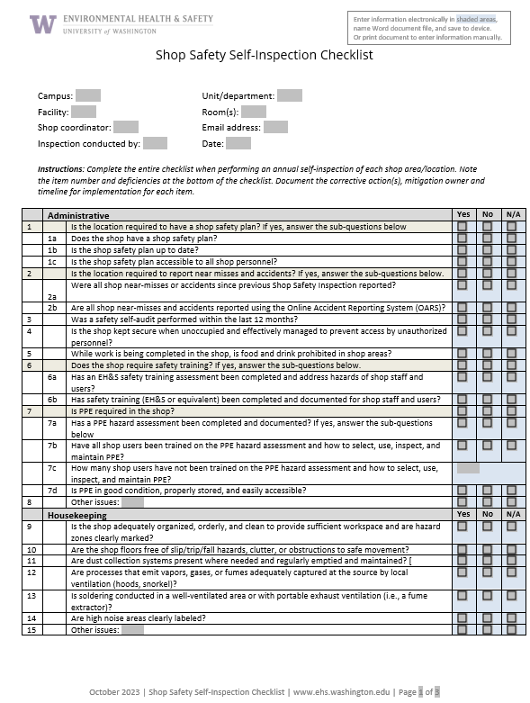
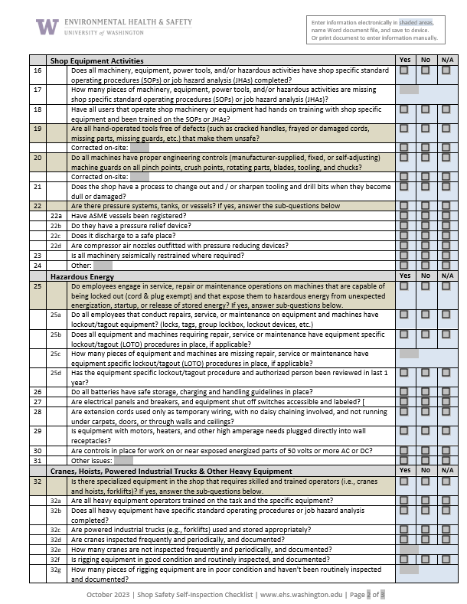
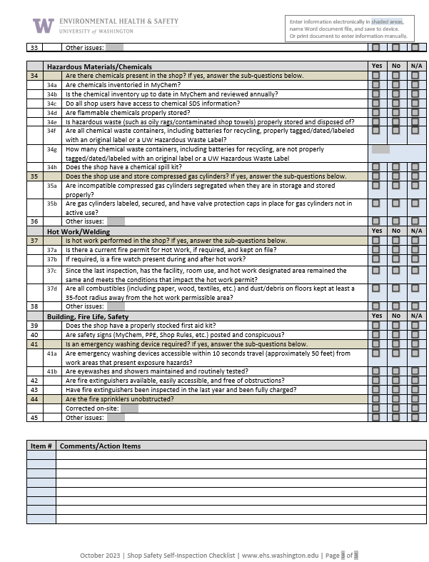

Appendix C: Training Records Logs
Instructions: Document formal and informal safety discussions, including meetings when the agenda includes any safety topics using one or more of the safety training record logs below. Document all safety discussions that may cover personal protective equipment, ventilation systems, specific chemical hazards, SDS access, chemical storage plans, machine guarding, fire safety, housekeeping, hot work, and other safety topics. Attach a training outline and other reference materials useful for training new personnel.
The Example Chemical Safety Training Log shows an example of a form that can be used to document a safety training session for a group. After being filled out, this form can be filed with the Shop Safety Plan. If filed separately from the Shop Safety Plan, the filing location should be noted in the Shop Safety Plan and the location made available to all shop personnel.

Example Shop Safety Training Log
Shop Safety Coordinator/Supervisor: Click or tap here to enter text.
Unit/Department: Click or tap here to enter text.
Date | Trainer | Trainees | Description of Safety Training
8/16/2023 | Denise Bender | AP # 1, AP #2, AP 3# | LOTO for Authorized Personnel
Click or tap here to enter text. | Click or tap here to enter text. | Click or tap here to enter text. | Click or tap here to enter text.
Click or tap here to enter text. | Click or tap here to enter text. | Click or tap here to enter text. | Click or tap here to enter text.
Click or tap here to enter text. | Click or tap here to enter text. | Click or tap here to enter text. | Click or tap here to enter text.
Click or tap here to enter text. | Click or tap here to enter text. | Click or tap here to enter text. | Click or tap here to enter text.
Click or tap here to enter text. | Click or tap here to enter text. | Click or tap here to enter text. | Click or tap here to enter text.
Click or tap here to enter text. | Click or tap here to enter text. | Click or tap here to enter text. | Click or tap here to enter text.
Click or tap here to enter text. | Click or tap here to enter text. | Click or tap here to enter text. | Click or tap here to enter text.

Equipment-Specific Safety Training Log
The Equipment-Specific Safety Training Log is a form that can be used to document training for an individual employee on shop equipment. Alternatively, the shop may choose to document training on a log within the equipment-specific SOP.
Is training for the use of specific equipment completed and documented in shop SOPs?
Yes No
List equipment-specific training below that is not documented in an SOP.
Shop Safety Coordinator/Supervisor: Click or tap here to enter text.
Trainee name: Click or tap here to enter text.

Name of Equipment | Policies and Practices Reviewed | Date
Click or tap here to enter text. | Yes | Click or tap to enter a date.
Click or tap here to enter text. | Yes | Click or tap to enter a date.
Click or tap here to enter text. | Yes | Click or tap to enter a date.
Click or tap here to enter text. | Yes | Click or tap to enter a date.
Click or tap here to enter text. | Yes | Click or tap to enter a date.
Click or tap here to enter text. | Yes | Click or tap to enter a date.
Click or tap here to enter text. | Yes | Click or tap to enter a date.

Shop-Specific Safety Training Log
The Shop-Specific Safety Training Log is a form that can be used to document training for an individual employee on shop-specific policies, procedures, and/or job hazard analyses. Alternatively, the shop may choose to document training on a log within an SOP or JHA.

Is training for specific procedures completed and documented in shop SOPs? Yes No
List specific procedure trainings below that are not documented on SOPs and/or JHAs.
Shop Safety Coordinator/Supervisor: Click or tap here to enter text.
Trainee name: Click or tap here to enter text.

Name of SOP/JHA | Policies and Practices Reviewed | Date
Click or tap here to enter text. | Yes | Click or tap to enter a date.
Click or tap here to enter text. | Yes | Click or tap to enter a date.
Click or tap here to enter text. | Yes | Click or tap to enter a date.
Click or tap here to enter text. | Yes | Click or tap to enter a date.
Click or tap here to enter text. | Yes | Click or tap to enter a date.

Additional Shop-Specific Safety Training Log
The Additional Shop-Specific Safety Training Log is a form that can be used to document training for an individual employee on shop-specific hazards or practices not documented elsewhere, such as confined spaces, lockout/tag-out, cranes and hoists, heavy operating equipment, etc.

Is additional training for hazards or practices not listed in the previous sections completed and documented for shop SOPs? Yes No
List specific procedure trainings below that are not documented on SOPs.
Shop Safety Coordinator/Supervisor: Click or tap here to enter text.
Trainee name: Click or tap here to enter text.

Name of Training | Policies and Practices Reviewed | Date
Click or tap here to enter text. | Yes | Click or tap to enter a date.
Click or tap here to enter text. | Yes | Click or tap to enter a date.
Click or tap here to enter text. | Yes | Click or tap to enter a date.
Click or tap here to enter text. | Yes | Click or tap to enter a date.
Click or tap here to enter text. | Yes | Click or tap to enter a date.
Click or tap here to enter text. | Yes | Click or tap to enter a date.

Appendix D: Machine safeguarding
Machine safeguarding is a key component of operating equipment safely in a shop or lab. The purpose of machine safeguarding is to protect the machine operator, and other personnel in the work area from hazards created by pinch points, rotating parts, flying chips, and sparks. Machine safeguards should be in conformity with any appropriate standards. The applicable machine safeguarding Washington Administrative Code standards are WAC 296-806-20027 through WAC 296-806-20042, depending on the machine and its operation.
A combination of safeguards (rigid barriers) and devices (interlocks, stop buttons) must be used to protect against the hazards of:
- Power transmission devices – belts, gears, flywheels, chains, pulleys, spindles, couplings, cams, machine components that transmit energy
- Points of operation – area where machine performs work on material; cutting, shearing, punching, bending, etc.
- Moving parts – reciprocating, rotating, traversing motions, auxiliary machine parts
- Flying chips, sparks, or fluids
- Falling objects
- Moving surfaces with hazards such as sharp edges, burrs, and protruding nails and bolts.
Any machine part, function, or process must be safeguarded to protect personnel from injury. Suppliers are responsible for ensuring that risk reduction measures are implemented as part of the design, construction, integration, and installation in accordance with all applicable laws, codes, and standards.
The unit/department is responsible for:
1. Identifying hazards and assessing risks associated with the machine and processes (using a job hazard analysis); and
2. Implementing risk reduction measures/controls (refer to the Machine Safeguarding Guide for commonly used machines and equipment); and
3. Ensuring the appropriate machine safeguarding is in place before use (following the Machine Guarding and Safety Assessment Self-Inspection Checklist).
Instructions: Risk reduction measures must be based on a risk assessment that is ideally performed by a team of people that operate and maintain the equipment/machines. A job hazard analysis (JHA) can be used to document the risk assessment for all tasks identified for the equipment/machine (e.g., setup, start-up, shutdown, inspection, servicing, maintenance, and repair. Based on the risk assessment, the type and number of controls may be selected based on the severity of the consequences identified. Typically, the higher the severity the more effective controls will be required, and the number of controls will likely increase.
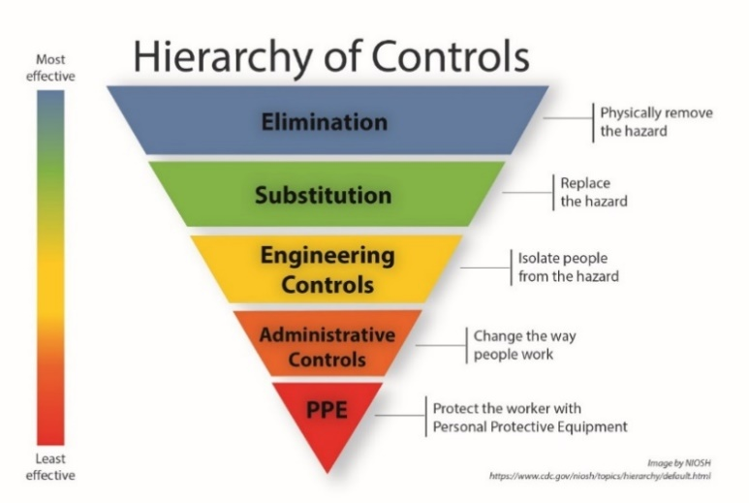
Use the Hierarchy of Controls (shown at right) to establish the acceptable level of risk for each accident scenario considered.

Hierarchy of Controls for machine safeguarding: Examples
Category | Control | Effectiveness at reducing risk
Elimination | - Eliminate pinch points  - Automate process  - Purchase machined parts and components | Most effective – eliminates hazards/risks
Substitution | - Redesign to reduce or eliminate human interaction  - Reduced energy  - Substitute less hazardous chemicals | Reduces the overall risk by reducing the level of severity of harm
Engineering Controls | - Guards  - Shields or barriers  - Safety Interlocks devices  - Pressure-sensing devices (safety curtains, safety mats)  - Two handed controls  - E-stops (push button/trip wire, foot-operated device) | Reduces the overall risk by reducing the likelihood or probability of harm  Minimal if any impact on the severity of harm
Administrative Controls | - Warning devices (e.g., lights beacons and strobes, horns)  - Signs and labels  - Awareness barriers | Potential to reduce the likelihood or probability of harm; Does not impact the severity of harm
PPE | - Safety glasses  - Face Shields  - Gloves  - Ear plugs  - Protective footwear  - Respirators | Potential to impact likelihood or probability of harm; Does not impact severity of harm

The Machine Guarding and Safety Assessment Self-Inspection Checklist on the EH&S website can be used in conjunction with the risk assessment to evaluate if the machine and machine operations are adequately safeguarded from the potential identified hazards and risks. Deficiencies identified by the risk assessment must be corrected prior to further use of the machine or equipment.

The information presented in the Machine Safeguarding Guide provides guidance on machine safeguarding and safe work practices when operating common shop equipment.

Appendix E: Signage and Labeling
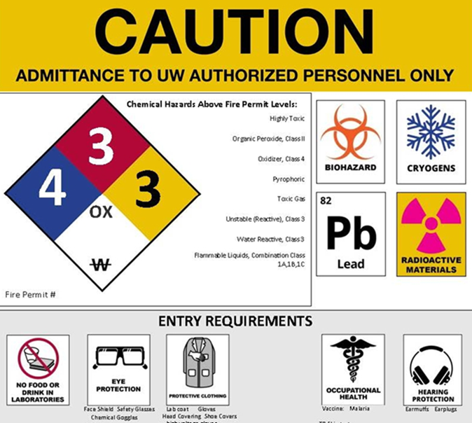
Shop safety signage is required to be placed at the shop entrance and within the shop as noted.

Required shop signage
Caution signs are required to be posted at the entrance to a space where hazardous materials are stored or used. The caution sign alerts emergency responders and visitors of potential hazards and precautions for entry (refer to the example at right). Visit the Caution and Warning Signs page on the EH&S website for more information on how to print a caution sign.
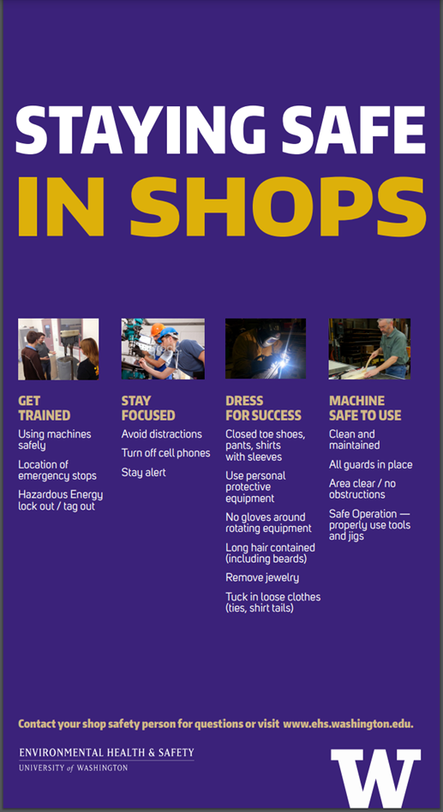
The Staying Safe In Shops poster is required to be posted at the shop entrance or within the shop space.

Recommended shop signage
Warning signs alert personnel to health and safety hazards present in the shop beyond those identified in the caution sign. Shop-specific PPE signage or signage indicating specific hazard warnings (refer to images below) are recommended to be placed adjacent to the hazard.
Contact EhsShop@uw.edu to request additional copies or PDFs of the signs.
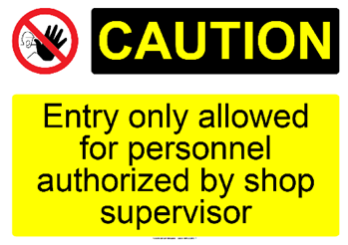
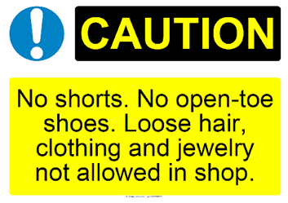

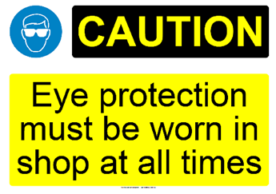

Chemical containers
Chemical containers must be labeled in accordance with the requirements outlined in the UW Chemical Hazard Communication Program Manual.
Download chemical container labels from the EH&S website and label all secondary chemical containers and chemical waste containers.

Piping systems
Piping systems must be labeled in accordance with the requirements outlined in the UW Chemical Hazard Communication Program Manual.
Local fire codes require that piping systems conveying hazardous materials are labeled in accordance with ANSI/ASME 13.1 Scheme for Identification of Piping Systems (shown below) and the UW Facility Design Standards for mechanical systems.
Instructions: Verify all piping systems in the shop are correctly labeled.
Figure 8 ANSI 13.1 Piping marking colors – updated 2007 standard
Color combinations | Hazardous material  (New standard: ASME A13.1-2007, R2013) | Hazardous material  (Old standard: ASME A13.1-1996, R2002)
WHITE on RED | Fire quenching fluids | Fire quenching fluids
BLACK on ORANGE | Toxic and corrosive fluids
BLACK on YELLOW | Flammable fluids | Hazardous materials  Flammable or explosive  Chemically active or toxic  Extreme temperatures or pressures  Radioactive
WHITE on BROWN | Combustible fluids
WHITE on GREEN | Potable, cooling, boiler feed, and other water | Low hazard materials
WHITE on BLUE | Compressed air | Low hazard gases
WHITE on PURPLE | User defined
BLACK on WHITE | User defined
WHITE on GRAY | User defined
WHITE on BLACK | User defined

UW personnel who work in laboratories should refer to the UW Laboratory Safety Manual for hazard communication and additional requirements specific to laboratory chemical use.

